Phase 5: Business Intelligence and Data Visualization
Objective
The objective of this phase is to transform the processed and structured data stored in the PostgreSQL data warehouse into meaningful business insights through interactive dashboards. Business Intelligence (BI) tools help decision-makers understand patterns, identify high-risk segments, and monitor overall portfolio performance.
For this project, Microsoft Power BI was used to design interactive dashboards that visualize credit risk patterns and loan distribution trends. The dashboards allow users to explore loan performance, borrower demographics, and default risk dynamically.

Dashboard Architecture
The BI layer directly connects to the PostgreSQL Data Warehouse, which was populated through the ETL pipeline. The warehouse stores cleaned and transformed loan data in structured fact and dimension tables.
The architecture of the visualization layer is as follows:
Raw Loan Data (CSV)
↓
ETL Pipeline (Python)
↓
PostgreSQL Data Warehouse
↓
Power BI Dashboard
This architecture enables efficient data analysis and real-time insights for credit risk monitoring.

Dashboard 1: Credit Risk Executive Overview

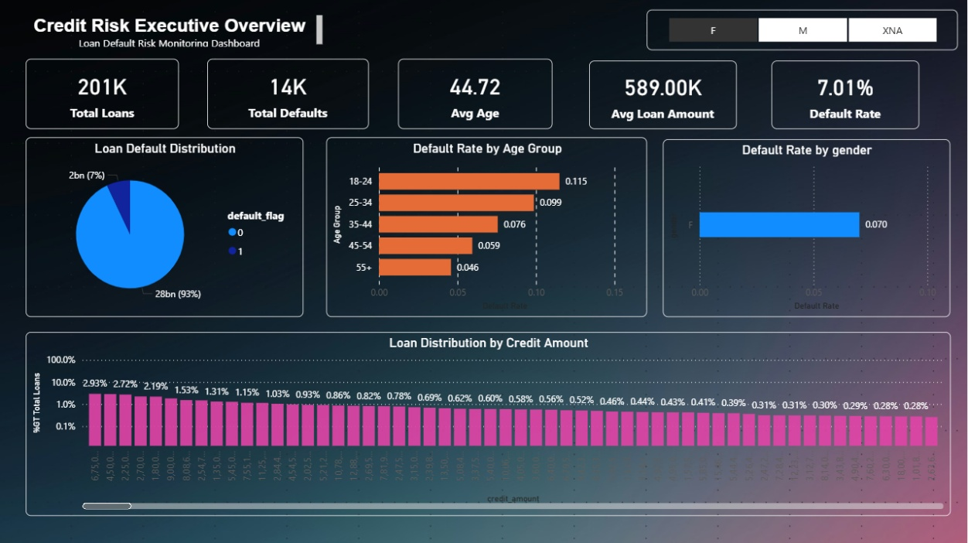

The Executive Overview Dashboard provides a high-level summary of the loan portfolio and key risk indicators. This dashboard is designed for managers and decision-makers to quickly evaluate portfolio health and monitor default trends.
Key Performance Indicators (KPIs)
The dashboard displays the following key metrics:
Total Loans
Represents the total number of loan applications in the dataset.
Total Defaults
Shows the number of loans that resulted in default.
Average Age of Borrowers
Provides the average age of customers in the loan portfolio.
Average Loan Amount
Indicates the average credit amount issued to borrowers.
Default Rate
Represents the percentage of loans that resulted in default.
These KPIs provide a quick overview of the credit portfolio and highlight potential risk exposure.

Loan Default Distribution
A pie chart is used to visualize the distribution of loans between:
- Non-defaulted loans
- Defaulted loans
This helps in understanding the overall portfolio risk level. In the current dataset, the majority of loans are non-defaulted, while a smaller percentage represents defaulted loans.

Default Rate by Age Group
A bar chart shows the relationship between borrower age and default rate.
Observations:
- Younger borrowers (18–24) show relatively higher default risk.
- Default rates decrease gradually for older age groups.
- Borrowers aged 55+ demonstrate the lowest risk levels.
This insight helps financial institutions identify high-risk age segments.

Default Rate by Gender
This visualization analyzes default behavior based on borrower gender.
Insights include:
- Differences in repayment behavior between male and female borrowers.
- Identification of demographic risk patterns.
This can help institutions refine risk scoring models and credit policies.

Loan Distribution by Credit Amount
A column chart illustrates how loans are distributed across different credit amount ranges.
Key insights include:
- Most loans are concentrated in lower and medium credit ranges.
- Larger loan amounts occur less frequently.
- Certain credit ranges may exhibit higher default patterns.
This analysis assists in evaluating exposure to high-value loans.

Dashboard 2: Risk Analysis

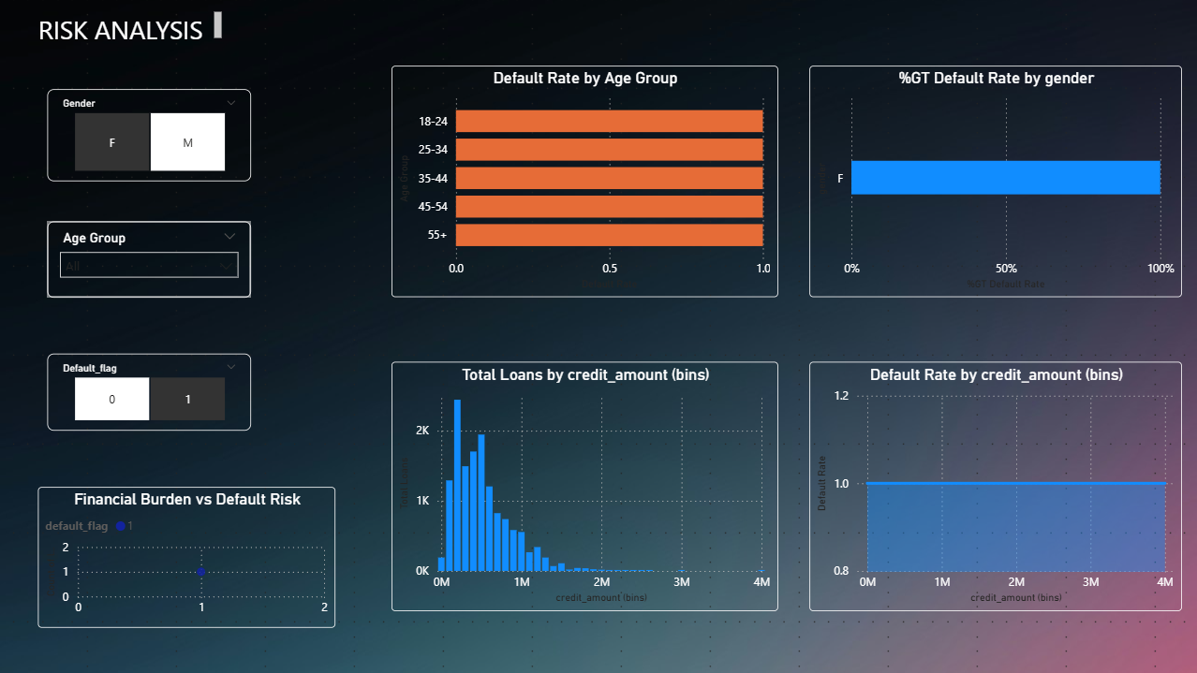

The Risk Analysis Dashboard provides a deeper analytical view of borrower risk characteristics and financial behavior.
Interactive filters allow users to explore loan data dynamically based on multiple criteria.

Interactive Filters
The dashboard includes the following slicers:
Gender Filter
Allows filtering loan data by borrower gender.
Age Group Filter
Allows users to analyze risk patterns across different age segments.
Default Flag Filter
Enables comparison between defaulted and non-defaulted loans.
These filters allow analysts to explore patterns across multiple dimensions.

Default Rate by Age Group
This chart highlights the relationship between borrower age and default probability.
Key observations:
- Younger borrowers tend to have higher default rates.
- Default risk gradually declines with increasing age.
- Middle-aged borrowers show moderate default risk.
These insights can be used to improve credit risk models and lending strategies.

Default Rate by Gender
This visualization compares default rates between genders.
The analysis helps institutions understand behavioral differences in loan repayment patterns and incorporate demographic risk factors into credit evaluation.

Loan Distribution by Credit Amount
A histogram is used to display how loan amounts are distributed across the portfolio.
Key findings:
- A large number of loans fall within lower credit ranges.
- High-value loans occur less frequently but may contribute significantly to risk exposure.

Default Rate by Credit Amount
This visualization shows how default probability varies with different loan amount ranges.
Insights include:
- Certain credit ranges exhibit higher default rates.
- Larger loans may carry higher financial risk.
This information can support better credit limit policies.

Financial Burden vs Default Risk
A scatter plot analyzes financial stress indicators such as:
- Loan-to-income ratio
- EMI burden
This helps identify borrowers who may be financially overextended.
Higher financial burden levels are often associated with increased default risk.

Business Insights Generated
The dashboard provides several valuable insights:
- Younger borrowers show relatively higher default probability.
- Loan size distribution indicates most loans are within lower credit ranges.
- Financial burden indicators help identify high-risk borrowers.
- Interactive filters allow detailed segmentation of borrower risk patterns.
These insights can assist financial institutions in improving credit approval strategies and managing loan portfolios more effectively.

Benefits of the BI Dashboard
The Power BI dashboard provides several advantages:
- Real-time visualization of loan portfolio performance
- Easy identification of high-risk borrower segments
- Interactive exploration of credit risk patterns
- Data-driven decision support for financial institutions
The dashboard transforms complex data into intuitive visual insights, making it easier for analysts and managers to monitor risk levels and optimize lending decisions.

Conclusion
The Business Intelligence phase successfully translates structured loan data into actionable insights through interactive dashboards. By integrating PostgreSQL data storage with Power BI visualization, the project demonstrates an end-to-end analytics workflow.
The dashboards enable users to analyze borrower behavior, identify risk trends, and monitor key financial indicators. This visualization layer enhances the overall system by providing a clear and accessible view of credit risk patterns within the loan portfolio.

